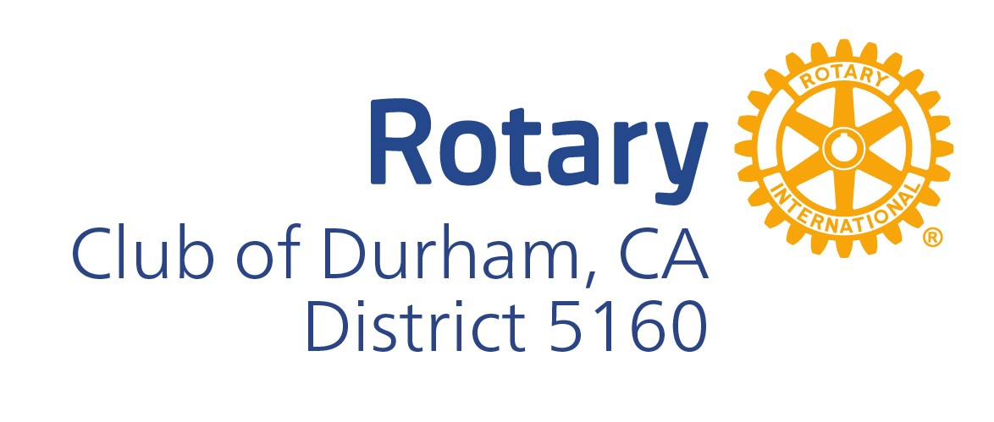

Information Sheet for Prospective Members

Our Club was chartered May 18, 1945

* About the Rotary International Organization
  + Found in 1905 by Paul Harris
  + Over 1.2 million Rotarians in our global network
  + 45,000 Rotary Clubs across the globe
  + Mission to provide service to others, promote integrity, and advance world understanding, goodwill and peace through our fellowship of business, professional, and community leaders.
* Our Club is governed by a Board of Directors
  + President, Treasurer, Secretary, President Elect, Immediate Past President.
  + The Club’s Board also includes Directors that are chairpersons of committees dedicated to carrying out the activities and responsibilities of our Club. The President appoints these Directors in advance of each Rotary year, and establishes their responsibilities.
* Avenues of Service
  + Club Service : participating in committees that support Club operations and activities.
  + Community Service : assisting in Club projects in our community. Harvest Festival, Crab Feed, Durham Parade and Picnic, etc.
  + International Service : participating in or supporting international projects through Rotary like wheelchair distribution, polio eradication, cleft pallet programs to name a few.
  + Youth Service : assist with continued development of our youth through service in Interact and with community service projects.
* New Member Selection Steps
  + A Candidate for Membership is proposed to the Club’s Board after attending at least (2) meetings.
  + The Candidate should complete the Club’s membership application at this point, to be reviewed by the Board.
  + An interview with the Candidate is conducted to get to know the proposed member, answer any questions, and explain what is expected. This includes time and financial obligations, as well as opportunities to help the Club and its mission.
  + The Candidate is “published” for review by the Club’s membership in the Rowel newsletter for 7 days.
  + If no objections by Board or Membership, the Candidate is inducted into the Club. Spouses and family are encouraged to attend the induction of the Candidate.
* What Our Members Receive
  + Fellowship with leading business, professional, vocational and government members of the community, region, and Rotary Clubs worldwide.
  + Community recognition as a member of a service club that is widely known and highly respected locally and internationally.
  + The opportunity to contribute time, talent and treasure to community projects alongside fellow Rotarians.
  + The ability to be welcomed at any Rotary Club worldwide.
  + Access to the Club directory and database.
* Financial Obligation
  + Dues are billed quarterly and include District Dues, Rotary International Dues, Club Dues and Meals.
  + Quarterly dues as of 1/1/2024 are $250.00
  + $100 minimum yearly recognition fee is in addition to quarterly dues. These funds help pay Club overhead costs.
  + Christmas Party attendance is not included in quarterly dues, and the fee to attend that is sent to membership annually as the event arrives.
* Attendance Commitment
  + Our meetings are bi-weekly on Tuesday evenings at 6:00-7:30 pm.
  + Meetings are typically held at Butte Creek Country Club, unless there is a schedule conflict with the venue. Alternate meeting locations are announced in advance at meetings, as well as in the bi-weekly Rowel and in email reminders.
  + Members are expected to RSVP for meeting attendance, including guests, by the Tuesday prior to the meeting so that BCCC can adequately prepare the venue and food for us.
  + Meeting attendance / engagement is important to the success of the Member, and the Club. Members with excessive missed meetings in a row with no communication to the Board could be cause for membership termination.